Multiple-choice section – choose the correct answer

Question 1 [5.1]

In mm2, the area of a rectangle of length 20 mm and width 1.5 cm is:

A 3 B 0.3 C 300 D 30

Question 2 [5.1]

The area of a circle of diameter 2 cm is approximately:

A 3.14 cm2 B 3140 m2 C 31.4 m2 D 314 m2

Question 3 [5.2]

The surface area of a rectangular prism of length 5 m, width 2 m and height 2 m is:

A 20 m2 B 24 m2 C 48 m2 D 81 m2

Question 4 [5.3]

A triangular prism has base length 6 cm, height 4 cm and depth 10 cm. Its volume is:

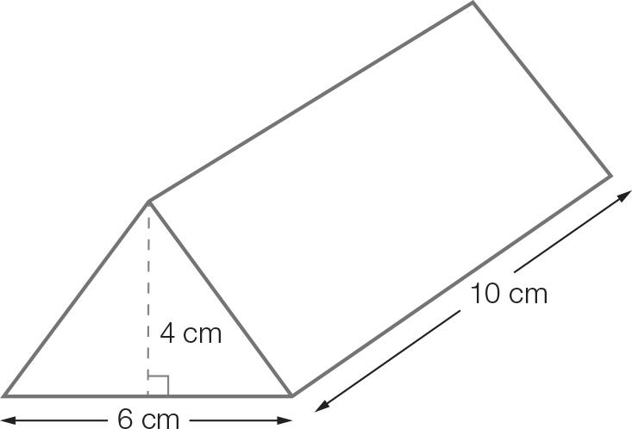

A 40 cm3 B 60 cm3 C 120 cm3 D 150 cm3

Question 5 [5.4] [10A]

A cone has base radius 2 cm and slant length 8 cm. Its surface area in cm2 is:

A 12.56 B 31.4 C 62.8 D 25.12

Question 6 [5.4] [10A]

The surface area of a sphere of diameter 2 cm, in m2 correct to 2 decimal places, is:

A 50.27 B 12.56 C 25.12 D 125.6

Question 7 [5.5] [10A]

The base radius of a cone is 5 cm and its height is 10 cm. The volume in cm3 is closest to:

A 3016 B 262 C 2262 D 4048

Question 8 [5.5] [10A]

A golf ball has radius 16 mm. Its volume in mm3 is closest to:

A 157 B 1357 C 5429 D 17 157

Question 9 [5.7] [10A]

A rock of mass 2 kg has volume 500 cm3. Its density in g/cm3 is:

A 4 g/cm3 B 40 g/cm3 C 10 g/cm3 D 100 g/cm3

Question 10 [5.7] [10A]

3 L of salt water contains 30 mL of salt solution. The concentration of the salt water in mL/L is:

A 0.02 B 5 C 20 D 50

Multiple-choice total marks: __ / 10

Short answer section

Question 11 2 marks [5.2, 5.4]

Use words from the list below to complete the following sentences.

surface area prism pyramid composite shape

capacity tapered solid density

(a) A three-dimensional shape whose cross-sectional area decreases uniformly is a ___________________________.

(b) The____________________________________ of a cube is the sum of the area of its six faces.

Question 12 2 marks [5.4] [10A]

What is the same about a cone and a pyramid?

Question 13 2 marks [5.1]

Calculate the area of the shape (in m2).

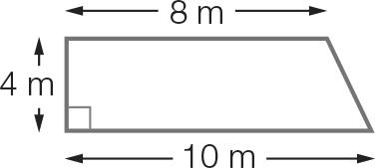

Question 14 2 marks [5.1]

A circle of diameter 26 cm fits inside a square and touches every side. Find the area of the square not in the circle. Give your answer correct to 2 decimal places.

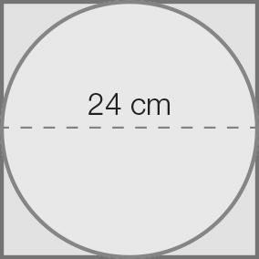

Question 15 3 marks [5.2]

Calculate the surface area of the figure.

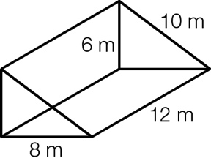

Question 16 2 marks [5.3]

Calculate the volume of a cylinder of height 20 cm and diameter 4 cm, correct to 2 decimal places.

Question 17 2 marks [5.5] [10A]

What is the volume of a rectangular-based pyramid of height 15 cm, where the length and width of the base is 8 cm and 12 cm respectively?

Question 18 3 marks [5.4] [10A]

Two cones with the same diameter of 10 cm are attached to form the shape. If the slant lengths  
are 7 cm and 6 cm, what is the total surface area, correct to 2 decimal places?

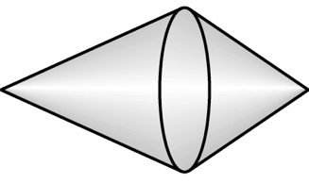

Question 19 3 marks [5.5] [10A]

Calculate the capacity, in litres, of a hemispherical bowl of diameter 18 cm. Give your answer correct  
to 2 decimal places.

Question 20 3 marks [5.2]

A cylindrical container of height 18 cm is open at one end. If the radius of the circular end is 10 cm,  
what is the external surface area, correct to 2 decimal places?

Question 21 3 marks [5.7] [10A]

Burst orange juice contains 10 g of orange concentrate in each 200 mL of water.

(a) Find the concentration of orange concentrate in g/L.

(b) How much concentrate is required for a 2.5 L carton of orange juice?

Question 22 2 marks [5.7] [10A]

A Chocco chocolate ball has diameter 3.2 mm. If a Chocco has a mass of 6 g, what is its density  
(in g/cm3)?

Question 23 4 marks [5.6]

The length c of the hypotenuse of a right-angled triangle is , where a and b are the lengths of the two shorter sides.

(a) Rearrange the equation to make b the subject.

(b) Calculate, correct to 2 decimal places, the value of b when a is 4.5 cm and c is 5.5 cm.

Question 24 3 marks [5.6]

(a) Rearrange  to make c the subject.

(b) Determine the value of c when a = 2 and b = 6.

Short answer total:_________/ 36

Extended answer section

Question 25 6 marks [5.3, 5.4, 5.5] [10A]

LP gas from a cylindrical tank is to be transferred to a new spherical tank.

(a) What is the volume in m3 of the cylindrical tank if it is 5 m high and 4 m in diameter? Give your answer correct to 2 decimal places

(b) What should be the radius of the spherical tank if it is to be completely filled by the transferred gas? Give your answer correct to 1 decimal place.

(c) The outside of the new spherical tank will be painted at a cost of $40/square metre. Hence find the total cost to the nearest dollar.

Question 26 5 marks [5.1, 5.3]

The perimeter of a gold pendant consists of a half circle, a quarter circle and a straight edge.

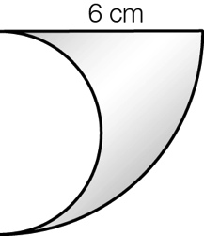

(a) Find the area, correct to 2 decimal places, of the quarter circle and the area of the semi-circle. Note that these two circles have different radii.

(b) To calculate the area of the front face of the pendant, subtract the area of the semicircle from the area of the quarter circle. Give your answer correct to 2 decimal places.

(c) Calculate the volume of the pendant assuming it is 2 cm thick, correct to 2 decimal places.

(d) The gold is melted and reused to make a gold coin of thickness 1 cm. If it is assumed that the coin is in the shape of a cylinder, what is its radius, correct to 2 decimal places?

Question 27 5 marks [5.4] [10A]

A witch’s hat is to be made from cardboard.

(a) What is the curved surface area of the cone? Give your answer in cm2, correct to 2 decimal places.

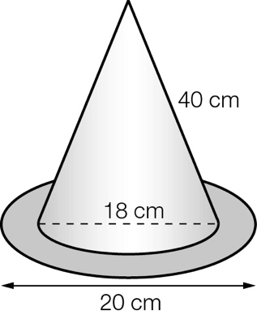

(b) Find the radius of each of the two circles in the brim. Use these to calculate the area of the brim, correct to 2 decimal places.

(c) What is the total area of paper required, correct to 2 decimal places?

Question 28 4 marks [5.3, 5.7]

A circular swimming pool of radius 2.6 m and depth 2.3 m is completely filled with water.

(a) What is the capacity, in litres, of the pool?

[10A] (b) Chlorine is added so that the concentration of the water is 0.3 g/L. How many kilograms of chlorine was required, correct to 2 decimal places?

Extended answer total:______/20

TOTAL test results: _____ / 66